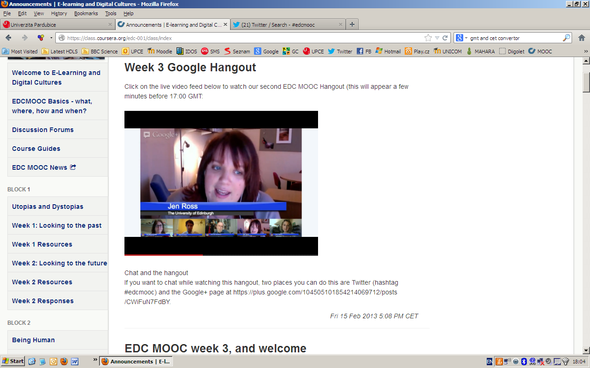

Jen Ross:
After the hangout – open for submission
27th February – submission closed

Hamish Macleaod

42874 users
7392 active last week
17% active
Google analytics – big activity, leveling off, plateau, evening GMT higher activity
Hits – 60% US, UK second
Survey:
EDC group
Other Edinborough course takers
Countries: US ¼ UK next biggest number
Business: most – teaching and education 60% of MOOC population
Highest academic level: 60% post graduate,

ACTIVE USERS:
Hitting the course platform, load on coursera platform, otherwise other blogs etc. Are not included

Survey: inconsistency, the course is still open

Sian Bayne – CONTENT

Chin stroking week
Humanism in the context of education
Usher and Edwards 1994
The role of the educator
What it means to be human?
Self-motivation, self-direction, self-hood, not about others
Individual agency
Full autonomy? Risk of connectiveness to fellow species
Critical post humanism

Images and their interpretation:
Agency: being human – means being connected
Normal to be connected all the time
Where are we going?
Time: having time to get to know people

Christine Sinclair

Study groups:
60+ group
A students group, should a teacher/professor join?
Rejecting native/immigrants
What we do not want to lose: Critical thinking, playing outside, choice
Comfort and respect
Tipping points

Signing up for some interest groups
Drifted, uncomfortable
Being in a group? Individual (extrovesion and introversion)
Informal groups
Groups are not for everyone
But we have a choice

Study groups in forums

Jeremy Knox

What does it mean being human?
The lecture: historical context, humanity has always been ambiguous.

Bifurcation?

Disembodyment in on-line learning – we can only learn about…

Modification – future education
Critique
Being humane or inhumane
Thinking about nature of reality
Progress – use technology to be better, to improve education
The idea – humanity means being more in touch with nature

Motivation for doing MOOC – Uni signed an agreement with coursera and then looked for the team
Digital education – business
Should do it
Grad students – accredited course is dealing with open courses, e-learning, experimenting with the massiveness and the uni course. It worked last week with the grad students.

Still access to all materials after the mooc ends
Twitter hashtag will go on
Facebook group
Google+ group

Christine Sinclair – Blackboard group, the platforms change, technology change and the things disappear and disintegrate…

The IDEA of the TALKING HEAD
What MOOCs are? Too early to say.

MOOC – good experience, exciting, early stage of MOOCs, an opportunity to experiment, experinece something new

Reassurance – people are comfortable with the way of learning

Pressure not to lose students

ARTEFACTS
define an artefact
Anything created, the researcher creates and did not mean to.
No answer
Copyright issues
A remix is a powerful way, experiment, judge on your own, reference the sources,
Good valuable judgement
EVALUATION: what makes a good artefact and clever argument
Plagiarism, copyright breech
How to approach the artefact?
Flickrs photo stream for inspiration, the MSc students can be a source of inspiration
Go back through the content of the course, what strikes you…
Look at the assessment criteria
Creatively look at the things
Be brave
Any key messages from the course
Deliver the message your own way
Images in Flickr
Make the images Creative commons licence!!!!
Media training

NEXT WEEK

WEEK 4:
Being Human
Transhumanism – enhancement
Adavntages of stepping beyond the human
Remain critical perspective



