Enhancing Language Learner Autonomy Through ePortfolio Use
Linda Pospíšilová
University of West Bohemia, Pilsen
University of Pardubice, Pardubice
Czech Republic
linda.pospisilova@upce.cz

Abstract: Nowadays, in compliance with the so-called 21st century skills, it is desired to provide our students with skills needed to become successful, autonomous, and reflective practitioners. Implementation of ePortfolio in the learning process seems to be a feasible solution to the above mentioned challenge. The aim of the author’s research is to examine the potential of ePortfolio use in language learning at tertiary level. The paper describes a pilot study of a course design enhanced by ePortfolio application and piloted in university students of English for Specific Purposes and the University of Pardubice, Czech Republic. 40 students of English for Economics and English for Chemistry are involved in the initial phase of the study with the aim to provide language learners with space for self-analysis and self-reflection followed by blended form of guided autonomous learning and subject learning. The study participants undergo several stages of language level assessment. Firstly, it is an initial ePlacement test; consequently, students go through self-assessment of their skills followed by standardized language testing. The results of tests are shared and discussed with the students with the focus on strong and weak skills. Each phase is concluded by setting learning objectives based on obtained test results and self-assessment forms. The process aims at formulation of partial, concrete, and achievable learning objectives. The main functions of portfolio are all present in the study phases: evaluation, growth, and showcasing functions. The ePortfolio represents both the role a personal learning space and simultaneously of a space designed for collecting artefacts which provide evidence of met objectives. The suggested teaching and learning model using ePortfolio to enhance reflection and autonomy in learners can be adjusted and applied in teaching and learning subjects of various fields thus increasing the learning experience and outcomes in the learning process.

Keywords: ePortfolio, self-reflection, autonomy, language learning, pilot study
1. Introduction
Use of portfolio in language learning has been in existence since 1991. It was proposed by David Little and a team of language specialist as a European Language Portfolio (ELP) and between 1998 and 2000 it was launched throughout Europe by the Council of Europe (Little 2011). Despite its elaborate structure and a mission not distant from the current trends including lifelong learning encouragement, transparency of learning, promotion of plurilingualism, and learner autonomy, the file consisting of a language passport, a language biography, and a dossier did not seem to be widely accepted and implemented in language teaching and learning. Twenty-five years later the same ideas are being promoted by technology experts worldwide encouraging use of ePortfolio across the fields and across the education levels claiming with similar arguments of lifelong learning, employability, and visualization of learning. One of the most frequent arguments for ePortfolio implementation today is its role in providing evidence of individual growth and personal accomplishments increasing user employability be it students or experienced employees searching for new jobs nationally or internationally.
2. The Role of ePortfolio in Language Learning
What is electronic portfolio? EPortfolio can be described as a collection of digital artefacts. As digital artefacts can be considered electronic documents, video, audio files, and images, etc. which serve as examples of student work and evidence of their learning over time. The artefacts should be collected and then selected with purpose and their assortment in collections should be justifiable. ePortfolio is usually introduced by the institutions as a form of learning assessment. Paulson & Paulson outlined contrasting paradigms of two models of portfolio assessment: Positivist and Constructivist paradigms. These portfolios then produce different activities.

Positivist Portfolios “The purpose of the portfolio is to assess learning outcomes and those outcomes are, generally, defined externally. Positivism assumes that meaning is constant across users, contexts, and purposes… The portfolio is a receptacle for examples of student work used to infer what and how much learning has occurred.” (p.8)

Constructivist Portfolios “The portfolio is a learning environment in which the learner constructs meaning. It assumes that meaning varies across individuals, over time, and with purpose. The portfolio presents process, a record of the processes associated with learning itself; a summation of individual portfolios would be too complex for normative description.” (pp. 8-9)

The ePortfolio was first introduced at the Language Centre of the University of Pardubice as a positivist portfolio. The students were and still are assigned tasks to be completed and displayed within their ePortfolio to be subsequently assessed according to given criteria. With the pilot study described in detail in chapter 5, constructivist portfolios were introduced to a team of involved teachers and their students. The aim of the pilot study is to enhance self-assessment and autonomy in students. These two phenomena will be further discussed in the following two chapters.

3. ePortfolio and Self-assessment
Assessment trough ePlacement, Progress, and Final Evaluation tests has been used by the Language Centre of the University Pardubice for several years. There are standardized tests allowing the department to place their students according to their current language level thus enabling the students to work on their progress more efficiently aiming at higher level achievement according to CEFR. Incorporation of self-assessment into the courses comes naturally with introduction of the ePortfolio in both ‘English for Specific Purposes’ and ‘English for Academic Purposes’ courses. In the pilot study students undergo a self-assessment cycle including setting goals and evidence collection during a time period of one term starting with the ePlacement test as demonstrated in the following scheme (Figure 1).

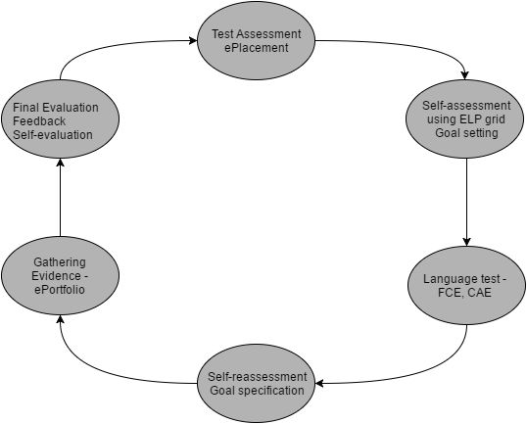
Figure 1: Self-assessment and Assessment cycle

4. ePortfolio and Autonomy
The concept of autonomy in language learning can be tracked back to the first European Council projects and research centres established in 1971. One of the prominent figures within the field of autonomy is Henri Holec. One of his earliest definitions describes autonomy as ‘the ability to take charge of one’s own learning’ (Holec 1981) meaning that the responsibility for the learning is taken by the learners themselves by determining the learning objectives, selecting methods and techniques of achieving the objectives and finally by evaluating what has been acquired (Benson 2013). The above mentioned principles of learner autonomy were applied when conducting the pilot study on self-assessment and portfolio implementation in language learning. According to Benson ‘Portfolios have also been seen as a useful tool for self-monitoring and self-assessment’ especially for student teachers, however, ‘research shows that learners are, under appropriate conditions and with appropriate training, able to self-assess their language performance, but it does not yet tell us much about how they make the process of self-assessment relevant to their own learning goals.’ The pilot study was run to test feasibility of the suggested teaching and learning model.

5. Pilot Study Description

5.1 Purpose of the Study
The primary purpose of the study was to pilot a proposed model of language teaching and learning and to find answers to the following questions: Can ePortfolio be successfully applied to enhance efficient language learning? Are students capable of self-assessment? Are they capable of self-assessment in the target language? Are students able to set their own language learning goals and further provide evidence of their fulfilment? How do students informally learn foreign languages?

5.2 Participants and Time Scope
There were 3 language teachers and 48 students participating in the first pilot study of the ePortfolio implementation with accent on self-assessment and learner autonomy enhancement. All three teachers are experienced users of Mahara ePortfolio tool with more than 2 years of practice in implementation of positivist portfolio in language teaching and learning. The students were selected according to two criteria: smaller groups of students were involved allowing individual approach to students. All three levels of tertiary education where English for Specific Purposes (ESP) or English for Academic Purposes (EAP) courses are offered were included. Another criterion for the participant selection was the language level. The teachers agreed on selecting the groups which are already expected to be capable of using the target language on the level required for self-analysis and also the participants were expected certain ability to work as independent language learners. For the above mentioned reasons, the levels of English language beginning with B1+ were included in the study. The participants of the pilot study were from two faculties of the University of Pardubice: Faculty of Chemical Technology and Faculty of Economics and Administration. The pilot study was designed for a period of one term and it was in progress from the end of February to the end of June 2016 covering 5 months including the teaching and examination period at the University of Pardubice.

5.3 Language ePortfolio Implementation Process
Firstly current language level of the students of both Bachelor and Master levels was diagnosed by means of a standardized institutional ePlacement English test and consequently students were enrolled in the language courses according to their level of English using CEFR. The courses currently offered by the Language Centre range from A2+ to C1 courses. Only the students of doctoral level do not undergo the initial placement procedure due to a different nature of their study which to the largest extend corresponds to the character of autonomous learning. The students in selected courses were assigned a language self-assessment and goal-setting task based on the CEFR can-do-statements grid. Subsequently the students were tested using one of the tests in compliance with their level determined by the ePlacement test. The tests can be seen in Table 1:

Table 1: Language tests and CEFR levels

Language Test and CEFR Levels
CEFR level  Reading | Standardized Language Test  EEWnglish  Total
A2 | KET (A Cambridge English: Key)
A2+/B1 | PET (A Cambridge English: Preliminary)
B1+/B2 | FCE (A Cambridge English: First)
C1 | CAE (A Cambridge English: Advanced)

The individual tests needed to be adopted in length, nevertheless, in all tests three language skills were included: Listening, Reading, and Use of English. Writing skill was excluded due to consistency with the ePlacement course and specific focus of the selected ESP courses. However, the self-assessment template also included the Writing skill to provide students with complex self-assessment criteria and furthermore taking into account informal language learning of students. In accordance with the Self-assessment cycle illustrated in Figure 1 the students together with their teachers revisited their Self-assessment Pages in their ePortfolio and reassessed their skill analysis and their personal objectives reflecting their language test results in each tested skill. The students consulted their goals and weaknesses with the teachers. The final part of the term was spent on skill improvement in and out of the language course and consultations on possible ways of self-improvement in a form of short guided sharing sessions among the students. The pilot study was concluded with the final self-evaluation and evaluation phase which composed part of the language exam and consisted of a presentation of learning evidence gathered by the students.

6. Results and Discussion
The pilot study was successfully carried out and concluded by all three teachers including the author of this article. All teachers together with their students went through all stages of the Self-assessment and final assessment cycle suggested in Figure 1. There were determined two key moments in the study. The progress test analysis revealing both students and teachers the areas for improvement and the goal-setting phase in which the students encountered difficulties creating general non-achievable goals with guided progress to tangible and achievable objectives. Example of goal-setting progress can be seen in Table 2 where the process of clarification of the goal can be observed and Table 3 outlines average results of the standardized tests from Table 1 which were administered in all selected courses. These test results provide both teachers and students with valuable information about the strongest and weakest skills in students across the levels and programmes. The outcomes show that the strongest skills of the students are Reading and Listening and the weakest skill is Use of English. After the testing and further test result analysis, the Use of English was the most requested part to be practiced by involved students.

Table 2: Goal-setting phase

Examples of goal-setting and goal-resetting phases
Goal 1  Reading | Goal 2 (reconsidered and reformulated)  EEWnglish  Total
I want to be better in listening. | I want to watch one video per week.  difference in speech.
I need to improve my grammar. | I will write sometimes a text and that will help  me in terminology and grammar.

Table 3: Language Skill Analysis
Table 3 is divided into 5 partial tables according to educational levels and CEFR levels of the students. The data in percentage demonstrate average results in each group and the grey fields show the strongest and weakest skill identified in each piloted group. These results can be further investigated and used in course design and language policy decisions.
Bachelor level
Skills analysis on B1+ target level: total of 7 Ss (1st year)
Listening | Reading | Use of E  EEWnglish | Total
83% | 72% | 73% | 78%

Skills analysis on C1 target level: total of 8 Ss
Listening | Reading | Use of E  EEWnglish | Total
58% | 85% | 56% | 67%

Master level
Skills analysis on B1+/B2 target level: total of 12 Ss
Listening | Reading | Use of E  EEWnglish | Total
55% | 39% | 45% | 49%

Skills analysis on B2+ target level: total of 9 Ss
Listening | Reading | Use of E  EEWnglish | Total
55% | 65% | 54% | 57%

Doctoral level
Skills analysis on C1 target level: total of 12 Ss
Listening | Reading | Use of E  EEWnglish | Total
45% | 60% | 38% | 47%

6.2 Evidence
The final phase of the Self-assessment and Assessment cycle consists of evidence presentation, overall self-assessment and final teacher’s assessment. The students prepare, share, and present a Self-assessment and Evidence Page created in their ePortfolio using the Mahara ePortfolio tool. The self-assessment page can be shared only with the teacher and its design allows teacher to see changes made to the page in real time. The Page structure can be seen in Figure 2. The Page is designed covering all assessed skills: Listening Comprehension, Reading Comprehension, Spoken Interaction, Spoken Production, and Writing. All these skills are assessed by the students themselves using can-do-statements from the template and by their means defining strong and weak points in each skill category. Each self-assessment part is concluded by setting an achievable and concrete goal to be fulfilled during the term. The final part in each column represents evidence of the goal fulfilment to be presented during the final self-assessment and assessment session.

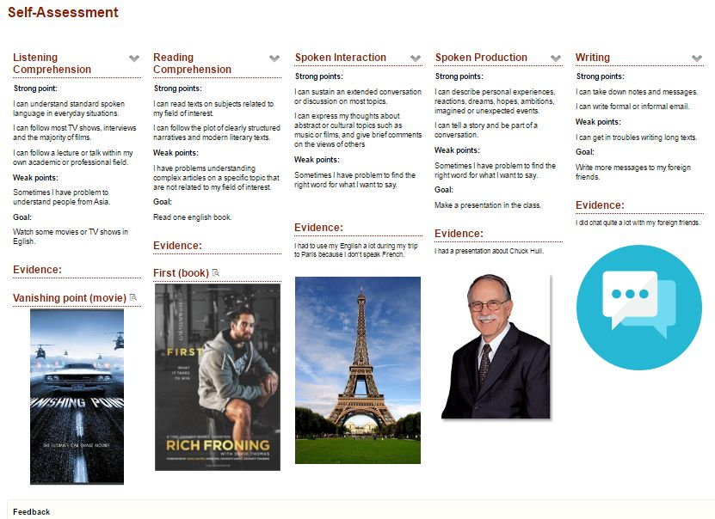
Figure 2: A Sample of Self-assessment and Evidence Page in Mahara ePortfolio

In the Table 4 there are selected examples of objectives and evidence demonstrating fulfilment or lack of fulfilment of the goals. Some students openly admitted the situation when they had not achieved expected results.

Table 4: From Objectives to Evidence

Examples of objectives and evidence provided by students
A Goal  Reading | Evidence  EEWnglish  Total
Every week I will read a short story, maybe I will try read some English book and I will search unknown words. | I read two english books last half year. I have read a short stories and articles from mobile phone application (English listening, speaking and reading)
I will read one english article per week. | In this point, I did not fill the objectives. I read only three english articles per semestr.

The final self-assessment and assessment process is framed by two forms adapted from The Hong Kong Polytechnic University. The first form is to be filled by the students and it summarizes what the students had learnt, their reflection on the learning process, and future plans and goals for further learning. The second form contains assessment criteria for ePortfolio Self-assessment and Evidence Page presentation. These two forms haven’t yet been piloted and tested in the time of writing this article.

7. Conclusion
The pilot study performed at the University of Pardubice in its language courses was aimed at enhancing student autonomy and self-assessment skills through ePortfolio use. The suggested self-assessment cycle was tested in 5 courses of all tertiary levels at the university at target language levels ranging from B1+ to C1 for the model feasibility. It can be concluded that the suggested model is feasible, nevertheless, the course content is demanding for both students and teachers likewise and students need to be trained to be able to assess themselves and to be capable of setting partial and achievable goals. However, when the goals are clearly set, the students are able to provide evidence of their learning. Within this short period of time, growth in student autonomy could already be observed and demonstrated by more frequent incidents of students approaching their teacher with requests for guidance and assistance with individual goal fulfilment. ePortfolio evidence pages need to be discussed with the students and further analysed in order to obtain answer to the question how the students learn informally. The model is to be repeated several times within the English language courses and more data is to be collected for further analysis.

References
Barrett, H. C. (2007) “Researching Electronic Portfolios and Learner Engagement: The REFLECT Initiative.” Journal of Adolescent & Adult Literacy, Vol. 50, pp 436–449.
Benson, P. (2013). Teaching and researching autonomy, second edition. Longman/Pearson, New York.
Cheng, G., Chau, J. (2013) “Exploring the relationship between students' self-regulated learning ability and their ePortfolio achievement” The Internet and Higher Education, Vol 17, pp 9 – 15.
Little, D., Goullier, F., Hughes, G. (2011) “The European Language Portfolio: the story so far (1991-2011)”, [online], Council of Europe, http://www.coe.int/en/web/portfolio/the-european-language-portfolio-the-story-so-far-1991-2011-executive-summary.
Paulson, F.L. & Paulson, P. (1994) “Assessing Portfolios Using the Constructivist Paradigm” in Fogarty, R. (ed.) (1996) Student Portfolios. Palatine: IRI Skylight Training & Publishing
The Common European Framework of Reference for Languages. Language Policy Division, Council of Europe, Strasbourg, www.coe.int/lang-CEFR

