Badging in Language Learning: A Step beyond Gamification |  | Pavel Brebera  Linda Pospíšilová
pavel.brebera@upce.cz; linda.pospisilova@upce.cz

Key words: digital badges, portfolio assessment, language learning, gamification, LMS Moodle
Abstract
The aim of the paper is to analyse the potential of digital badges in the area of language learning in the field of formal university education and their potential extension towards other meaningful learning contexts. With reference to their previous publications, the authors deal with the following theoretical aspects of the topic: the role of digital badges within the so called authentic assessment by means of portfolio, the potential of digital badges in the area of establishing meaningful links between formal, non-formal and informal learning, and the redefinition of the conceptual framework of “badging” in the Czech educational context. In their paper, the authors therefore formulate an urgent call for an extension of the scope of “badging” in formal education beyond the concept of gamification, i.e. towards the use of badges in broader contexts. As an empirical evidence for this claim, the authors present the outcomes of a small-scale investigation into the students’ subjective perceptions of “badging” in LMS Moodle carried out from the perspective of the influential Bartle’s typology of players, together with the descriptive data related to a large-scale use of digital badges in the language courses at the University of Pardubice during the previous 2 years.

ISSN: 1804-0527 (online) 1804-0519 (print)

Introduction
An ongoing integration of the use of ICT into various fields of education generates many expectations related to the potential of particular didactical means (both in terms of the equipment as well as the methods) which have been recently emerging in various educational contexts. One of the specific areas which have been massively discussed with reference to current trends in eLearning is the concept of digital badges, which has been demonstrating a huge development especially due to the efforts of the representatives of Mozilla community carried out after the launch of the Open Badges project in 2011 (Surman, 2011). Since then, numerous attempts to exploit the potential of digital badges in the area of education have been experienced and analysed in various educational contexts - for American experience see e.g. Ahn et al., 2014; in European context some very valuable insights with references to LMS Moodle are provided by Gavin, 2013b; very inspiring efforts coming from German environment are presented by Buchem, 2015.
In this paper, we aim to add our small contribution to the global debate on the potential and limitations of the use of digital badges for educational purposes and therefore, we intend (in line with our previous publications - Brebera, Pospíšilová 2014a, 2014b) to offer our specific perspective represented by “the voice” of the foreign language education in the Czech university setting. Being aware of some potential dangers of over-spontaneous and unmethodical use of new IT tools in the area of formal language education which can, according to Gonzáles and Ortega (2014, p.3) become “nothing more than entertainment unless their design, use, and evaluation are guided by viable educational and language development rationale”, the theoretical justification of the use of digital badges in language learning was formulated with reference to the concept of the so called authentic assessment in terms of portfolio and its functions, namely its diagnostic function, i.e. focus on the situation at this moment; self-reviewing function, i.e. focus on past achievements; and planning function, i.e. focus on formulation of future objectives (Brebera, Pospíšilová 2014a, 2014b with references to Píšová 2007). In this way, a desirable solid basis for the use of badges specifically in the area of foreign language education was established, both at the level of increasing learner motivation as well as providing a powerful assessment tool (for more about the relationship between motivation and assessment in connection to the use of badges in education see e.g. Abramovich et al. 2013). However, from a broader educational perspective, the inspiration for the use of digital badges in our context arises from some more general areas, which are presented in the following overview.

Broader perspectives on the use of digital badges: sources of inspiration

- Tradition of alternative pedagogy
A search for the most suitable theoretical perspective for introducing the concept of digital badges determining its systematic use across the area of foreign language education in university setting was guided by the curricular philosophy of the so called progressivism, including both the category of personal progressivism focusing on reflecting the specific needs and interests of the students and the so called social progressivism aimed at preparing the student for the life in democratic society (according to Pasch et al., 1998, p. 34). Accordingly, the inspiration for the use of digital badges for both motivational and certification purposes (i.e. both the partial badges informing the student about the current progress in his learning throughout the course as well as the final formal university badge providing the student with the credential of mastery of the specific content / development of specific skills at a certain level) was found in the tradition of the pedagogy of the so called Dalton plan (developed by Helen Parkhurst in 1922), which represents a specific pedagogical alternative arising from the American philosophy of pragmatism. The main features of the Dalton plan (especially its aspects of being an open system, its flexibility, activity, differentiation, specific teaching style, efficiency - see for example Rýdl 1998, pp. 27-33) as well as some of the specific tools used in Dalton schools (special boards for planning and for achievement, various ways of visualising and displaying students’ progress, various options for structuring the assignments and providing feedback on them – for more, see e.g. Wenke, Röhner 2000; Röhner, Wenke, 2003) provided the necessary background for our use of badges as the organisational principle of the language courses in LMS Moodle (for more about the content of these courses see Brebera, Pospíšilová 2014a, 2014b).

- Current trends in use of badges in the field of education
The above mentioned aspects of openness definitely transcend the area of pedagogical traditions of the last century as they form a very powerful incentive also for the development of those current educational trends which draw on the potential of digital badges. The highest degree of development of this particular issue can be observed in American educational context, especially due to the richest experience with the use of digital badges both for motivational and for certification purposes and the related analyses of not only their potential but also limitations. A very inspiring overview of some “potential questions and tensions at the intersection of open systems and badges” was recently provided by Ahn et al. (2014, p. 8) whose categorisation of badges as motivators, pedagogical tools and credentials is complemented by pointing out some dilemmas and contradictions related to the aspects of open production (what it may mean if anyone can create badges), open access (what it may mean if badges are widely accessible and visible) and open appropriation (what it may mean if badges are open to diverse interpretation by different stakeholders). In future, similar incentives will have to be thoroughly re-considered since the concept of badges as micro-credentials “at granular level” (i.e. for specific skills or pieces of knowledge – see e.g. Swanson 2014, p.4) is becoming very attractive for designing various scenarios of certifying skills and knowledge in the future (ibid).

- Gamification within formal and informal learning
Another area demonstrating an immense volume of openness in terms of potential use of badges in education is the so called gamification, generally considered as “the application of game elements to non-game contexts” (TechnologyAdvice 2014). Focusing on either cognitive or behaviouristic aspects of pure game-playing certainly demonstrates a huge potential for creating various typologies of game-players, such as for example the influential categorisation which was carried out by Bartle (1996), which is frequently quoted also in relation to gamification in non-game contexts. From our perspective, gamification represents a very influential cross-curricular phenomenon entering all three relevant domains of learning, namely “institutionalised formal learning, non-formal learning occurring in formal learning environments but not formally recognised (e.g. workshops, interest based courses, conferences) and informal learning of rather incidental or random nature” (Brebera, Hloušková, 2012, p. 275). Therefore, the acceptance of badges to the field of formal education is often accompanied by a certain degree of disregard in pedagogical communities, mainly due to their close links to the areas outside the domain of formal learning, as they are often perceived as a mere gamification tool (such as within Gavin’s Moodle Gamification Toolkit, 2013a, etc.) with a limited impact. From this perspective, a clearer distinction between the concepts of game and gamification (presented for example by Gavalcová 2014, pp. 83-85) might strengthen the position of digital badges among other didactical means available in current teaching/learning contexts.

The omnipresent nature of learning, the variety of available learning contexts and also the openness related to a potential use of badges in various fields of education with various purposes represent the re-defined framework of “badging” as a continual and meaningful process, extending its scope beyond the stereotype commonly formulated in terms of “badges equal gamification” towards the concept of “badging” forming an integral part of education.

Empirical research
Our investigation was carried out by means of a questionnaire survey administered to the students via Moodle during the final stage of the study in their respective courses. Two types of questions were included: questions focused on self-perceptions (cognitive and affective aspects) and questions focused on mapping up the former experience with badges (behavioural aspects and contextual factors). Methodological triangulation of our empirical research was not performed by means of multiple methods (as the only data collection technique was the above mentioned questionnaire) but it occurred at the level of multiple researchers involved (two participating teachers of Moodle courses). Besides, the clarification of the key concepts representing Bartle’s typology was pretested within the team of five language teachers whose comments were carefully considered and consequently reflected in modification of the content of the survey questions. The data analysis techniques stayed at level of quantifying the collected data at a descriptive level which, however, proved to be sufficient for the interpretation of our research results.
In our empirical investigation, we focused on the areas determined by three research questions. The charts related to the following interpretation of empirical data can be found in the Appendices at the end of this paper.

- What were the students’ perceptions of digital badges used in English language courses during the first and the second pilot year (2013-14 and 2014-15)?
During the whole period of 2 pilot years, 512 responses were collected in the form of feedback on the particular sets of digital badges used in the language courses taught at the University of Pardubice at the Faculty of Economics and Administration, Transport Faculty and Faculty of Chemical Technology. The students who participated in the two-semester courses were therefore asked twice. As it can be seen from Chart 1, the overall summary demonstrates mostly positive acceptance of digital badges in our university context since only 15% of the respondents demonstrated disagreement with the use of digital badges (mostly “slight” disagreement), while 49% expressed their positive attitudes towards the use of badges in their language courses.
Based on the comparison of the data from both pilot years (Charts 2 and 3), a visible change can be observed in terms of the increasing number of positive perceptions of digital badges (57% of either slightly or strongly positive perceptions in the second year compared to 41% in the first year of the badge implementation project) and the decrease in the number of negative ones (represented by their reduction by 8%) as well as the drop in the number of indifferent users (from 40% to 32%).

- Are there any tendencies in terms of the students’ experience with the digital badges in broader context, i.e. outside the university setting, in the first and the second pilot year?
Unlike the previous question about the perception of badges in relation to each specific Moodle course, the investigation of contextual factors related to badges in terms of the students’ previous experience outside the university context was not dependant on the particular courses and therefore, it was asked only once to the participants of the courses, i.e. 298 responses were collected.
The data show that the expected tendency in terms of a growing students’ exposure to the phenomenon of digital badges outside the university setting did not take place. The differences between the previous experience with digital badges in the first and the second pilot years are very small (7% in the first year compared to 10% in the second year) and due to these low numbers, also the related expected impact of the “badges from outside” seems to be negligible. However, the “unexperienced” group has been constantly demonstrating a huge potential in terms of the future use of digital badges in contexts outside the university setting (in the first year, 76% of this group expressed either slightly or strongly positive perceptions, and in the second year, this phenomenon concerned also 72% respondents).

- What are the specific patterns of students’ self-perception of their own behaviour in Moodle courses with the use of digital badges in terms of frequently quoted Bartle’s typology of players?
During the summer semester of the year 2014-15 (March-May 2015), the responses of 159 participants of the courses in Moodle were collected by means of a short questionnaire, which consisted of 8 questions. All four questions were formulated with the aim of choosing the particular behavioural patterns of the specific Bartle’s category (achiever, explorer, socialiser, killer), two of these questions focusing on Moodle and two of them on digital badges; each question in both categories of Moodle and digital badges representing either the dimension of “current view” and “perspective view”. The key concepts in the questions were carefully considered with reference to the students’ framework of experience (i.e. achiever - the aspects of progress, explorer – the aspects of interest in using and exploring of both systems that the students are currently familiar with, i.e. Moodle and STAG (Study Agenda), or the interest in additional aspects of badges, such as graphics; socialiser – the aspect of appreciation of other participants’ presence in Moodle; killer – the aspects of competing with other participants). The respondents were allowed to choose more options as the behavioural pattern would not supposedly exist in its pure form.
The overall summary (Chart 7) confirmed that the primary theoretical perspective of the use of badges in Moodle in accordance with the curricular philosophy of progressivism was perceived as dominant also by the majority of students who can see the highest value in the concept of progress, both provided by Moodle and measured/identified by badges. Besides, the comparison of overall summaries of responses in the category “achiever” for Moodle as well as for digital badges does not manifest big differences (204 identifications with this category in two questions asked about Moodle and 208 identifications with this category in two questions asked about badges). The comparable numbers of self-identifications related both to Moodle and digital badges (though at a much lower level) can be seen also in the category of killers (49 identifications with this category in two questions asked about Moodle and 47 identifications with this category in two questions asked about badges). On the other hand, the number of respondents who perceived themselves as “explorers” with reference to Moodle (157 responses commenting on the favourable broad scope of possibilities in Moodle or expressing the interest of exploring links between Moodle and STAG) is much higher than the number of “explorers” in terms of digital badges (only 55 of responses agreeing that digital badges certify that “I am good with Moodle” or expressing the interest in learning how to create badges by themselves). Similar variability, though with an opposite tendency, can be observed in case of self-perceptions in the category of “socialiser”, demonstrating larger intensity in the area of digital badges (referring to other holders of the same badge and expressing the wish to use social networks for displaying the badges – 57 responses) compared to a small number of socialising-oriented comments related to Moodle environment (representing the awareness of co-existence with other people in Moodle – 26 responses).
The following step of the analysis of the collected self-perceptions is to be carried out at an individual level of the particular participants in the courses, i.e. focusing on typical combinations of the responses representing Bartle’s categories in the dimensions “Moodle” and “digital badges”, and in the dimensions “current” and “perspective”, together with the relationship between the type of attitude towards digital badges (ranging from “very discouraging” towards “very encouraging”); this analysis is, however, beyond the scope of this article.

Conclusion
If we look at the above presented summary of empirical data from the perspective of the previously mentioned theoretical considerations we may conclude that the field of gamification certainly provides some very useful and powerful stimuli which are capable of triggering the “digital badge projects” in various educational settings. The categories of Bartle’s typology seem to provide a very inspiring way of structuring some possible uses of digital badges in the courses in LMS Moodle as they address the relevant aspects of measuring progress, stimulating the curiousness, providing the opportunities for online socialisation as well developing the group dynamics in online environment. However, we assume that a long-term effectiveness of the methodologies related to the use of digital badges could be sustainable only if a clear curricular concept is determined beforehand. Therefore, the use of digital badges representing a desired step beyond the concept of gamification is in our context justifiable and viable (according to the empirical evidence) mainly due to its sound basis in the philosophy of progressivism.

References

Abramovich, S. et al., 2013. “Are badges useful in education?: it depends upon the type of badge and expertise of learner.” Educational Technology Research and Development, Volume 61, Issue 2, April 2013, pp 217-232. ISSN 1042-1629.
Ahn, J. et al., 2014. “Open Badges for Education: what are the implications at the intersection of open systems and badging.” Research in Learning Technology, 2014, 22. http://www.researchinlearningtechnology.net/index.php/rlt/article/view/23563, accessed on 20th May 2015.
Bartle, R., 1996. “Hearts, Clubs, Diamonds, Spades: Players who suit MUDs”. http://mud.co.uk/richard/hcds.htm , accessed on 20th May 2015.
Brebera, P. ; Pospíšilová, L., 2014a. “Digital Badges as an Organisational Principle of the Language Course”. Conference Proceedings: ICT for Language Learning. 7th edition. Firenze, libreriauniversitaria.it, pp. 167-172. ISBN 978-88-6292-548-8.
Brebera, P. ; Pospíšilová, L., 2014b. “Využití „Badges“ v kurzech odborného anglického jazyka v LMS Moodle”. Sborník příspěvků z konference a soutěže eLearning 2014. Hradec Králové, Gaudeamus, pp. 8-13. ISBN 978-80-7435-481-6.
Brebera, P.; Hloušková, J., 2012. “Searching for Bridges between Formal and Informal Language Education”. Proceedings of the IADIS International Conference on Cognition and Exploratory Learning in the Digital Age (CELDA 2012). Lisbon, IADIS Press, pp. 274-277. ISBN 978-989-8533-12-8.
Buchem, I., 2015. “Open Badges for Recognition of Learning and Online Reputation”, eMadrid: Badges for the Recognition of Learning in the Digital Age. http://www.slideshare.net/ibuchem/open-badges-for-recognition-of-learning-and-online-reputation, accessed on 20th May 2015.
Gavalcová, T., 2014 “Předměty s matematickým obsahem: jak usnadnit úvodní etapy jejich studia na vysoké škole”. Sborník příspěvků z konference a soutěže eLearning 2014. Hradec Králové, Gaudeamus, pp. 81-86. ISBN 978-80-7435-481-6.
Gavin, H., 2013a. “Moodle Gamification Toolkit”, http://www.slideshare.net/ghenrick/moodle-gamification-tools-edtech-2013?next_slideshow=1 , accessed on 20th May 2015.
Gavin, H., 2013b. “Open Badges and Moodle – What and Why”, http://www.slideshare.net/ghenrick/open-badges-and-moodle-what-and-why , accessed on 20th May 2015.
Gonzáles-Lloret, M.; Ortega, M., 2014. “Technology-mediated TBLT. Researching Technology and Tasks”. Philadelphia, John Benjamins Publishing Company. ISBN 9789027207272.
Pasch, M. et al. 1998. “Od vzdělávacího programu k vyučovací hodině”. Praha, Portál. ISBN 80-7178-127-4.
Píšová, M. 2007. “Portfolio v profesní přípravě učitele – otazníky, naděje, nebezpečí.” Portfolio v profesní přípravě učitele. pp. 39-52. Univerzita Pardubice. ISBN 978-80-7395-024-8.
Röhner, R., Wenke, H. 2003. “Daltonské vyučování: stále živá inspirace”. Brno, Paido. ISBN 80-7315-041-7.
Rýdl, K., 1998. “Jak dosáhnout spoluzodpovědnosti žáka”. Praha, Strom. ISBN 80-86106-03-9.
Surman, M., 2011. “The Mozilla Blog”, https://blog.mozilla.org/blog/2011/09/15/openbadges/, accessed on 20th May 2015.
Swanson, J., 2015. “Certifying Skills and Knowledge: Four Scenarios on the Future of Credentials”. http://knowledgeworks.org/certifying-skills-and-knowledge-four-scenarios-future-credentials, accessed on 20th May 2015.
TechnologyAdvice, 2014. “Gamification 101: Learn the Basics of Gamification Strategy”. http://www.slideshare.net/technologyadvice/gamification-101-how-gami?related=1, accessed on 20th May 2015.
Wenke, H.; Röhner, R., 2000. “Ať žije škola”. Brno, Paido. ISBN 80-85931-82-6.
Appendices:
Chart 1. Summary of students’ perceptions (2013-2015)
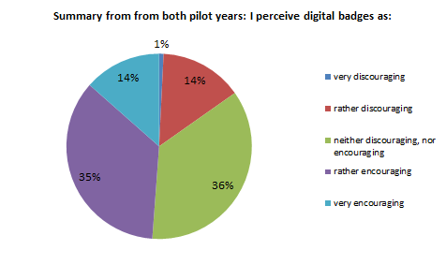

Chart 2. Students’ perceptions of digital badges during the pilot year 1 (2013-14)
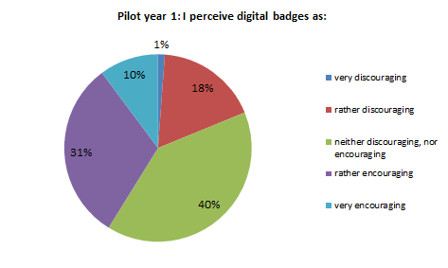

Chart 3. Students’ perceptions of digital badges during the pilot year 2 (2014-15)
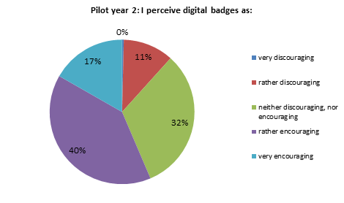

Chart 4. Summary of students’ broader experience with digital badges (2014-15)
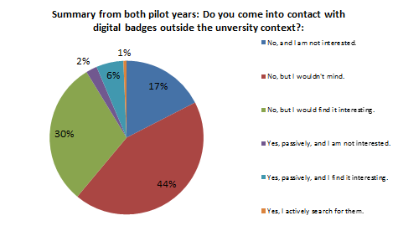

Chart 5. Students’ broader experience with digital badges (Pilot year 1: 2013-14)
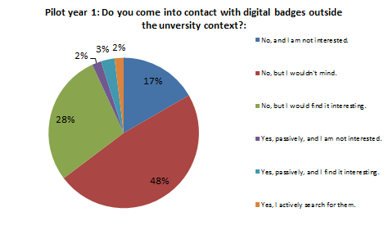

Chart 6. Students’ broader experience with digital badges (Pilot year 2: 2014-15)
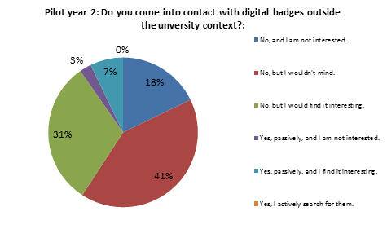

Chart 7. Bartle’s categories - summary of responses related either to Moodle or to badges
